**Welcome to A level Biology**

**Pre-enrolment activity**

A level Biology

**TASK 1**

**Activity: Microscopes**

1. Use the link to remind yourself how to use a microscope to view cells

<https://www.bbc.co.uk/bitesize/guides/z84jtv4/revision/4>

1. Produce a table to compare

* a light microscope
* a transmission electron microscope
* a scanning electron microscope

You could include how they work, advantages and disadvantages

1. What rules do you need to follow to produce a biological drawing of what you see down the microscope?

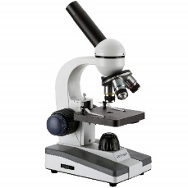

Now that we’ve done a little work on microscopes, it’s time to think about what we can use them to view by creating your own cell:

**TASK 2**

**Activity: Making a cell**

1. **Make a model cell containing the following parts**

* cell-surface membrane
* nucleus
* mitochondria
* Golgi apparatus and Golgi vesicles
* lysosomes (a type of Golgi vesicle that releases lysozymes)
* ribosomes
* rough endoplasmic reticulum and smooth endoplasmic reticulum

1. What parts would you need to add to transform your creation into a plant cell?

In complex multicellular organisms, cells become specialised for specific functions. Specialised cells are then organised.

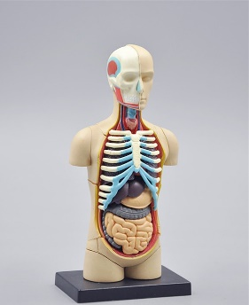**TASK 3**

**Activity: Organisation**

Research the following questions

1. Define tissue, organ and organ system
2. Give an example from the body of each
3. Produce a fact sheet on the digestive system

There are many different areas that nurses can specialise in, if you were to become a nurse which area would interest you and why?

**TASK 4**

We start the course looking at Biological molecules. Make sure you are fully prepared for the start of the year by watching the following videos and carrying out the tasks on Seneca Learning below.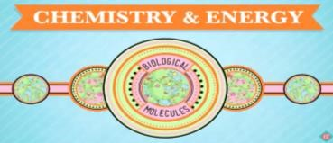

**Biological molecules** <https://www.youtube.com/watch?v=H8WJ2KENlK0>

**Welcome to Biology https://www.youtube.com/watch?v=7L7x0BAqWis**

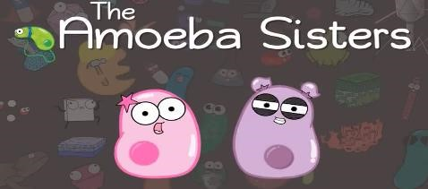

**Protein folding** <https://www.youtube.com/watch?v=hok2hyED9go>

**Access Seneca Learning** (if the link does not work then copy and paste into your browser)

<https://app.senecalearning.com/classroom/course/d0ce0c30-6417-11e8-8edc-d9cd1c890408/section/d4230390-6417-11e8-8edc-d9cd1c890408/session>

Complete Biological Molecules sections 1.1 and 1.2

**Equipment list**

**You must come to college prepared to learn with the following equipment every lesson:**

Black pen; red pen; pencil; sharpener; A4 ruler; eraser; scientific calculator; highlighter; lab coat (optional).

A4 Lined paper pad.

A4 lever arch file with at least 11 dividers – This is to keep all of your work in.

**Recommended books and wider reading**

The biology department will provide printed theory booklets with exam-style question packs for all students, however wider reading resources are required. Please see the recommended materials below. You will be able to order and pay for textbooks and revision guides with the college.

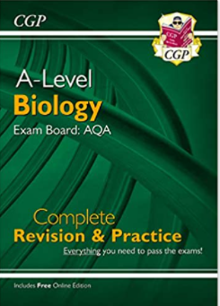  @RoyalSocBio  @BSRHodder@newscientist

**TASK 5**

It is important that you start/continue thinking about the many possible career options that biology can offer.

**1.Watch the introduction video to careers in Biology:**

[Bing Videos](https://www.bing.com/videos/riverview/relatedvideo?&q=professional+career+videos+biology&qpvt=professional+career+videos+biology&mid=B90F631662168A1F0133B90F631662168A1F0133&mmscn=mtsc&aps=5&FORM=VRDGAR)

Video title: Careers in Biology | Careers | Biology | FuseSchool

**2: Choose one of the following sites to research potential careers:**

[What can I do with a biology degree? | Prospects.ac.uk](https://www.prospects.ac.uk/careers-advice/what-can-i-do-with-my-degree/biology)

[Biological Science Jobs Profiles](https://career-advice.jobs.ac.uk/resources/job-profiles/biological-science-jobs/)

**Complete the research table below.**

**3: Read about some case studies from professionals in scientific careers:**

[Academic Case Studies - career-advice.jobs.ac.uk](https://career-advice.jobs.ac.uk/resources/academic-case-studies/)

**4: Watch some case study Video talks by world-class scientists who share the excitement of making discoveries, how they became scientists, and other interesting biology topics:**

[**T**alks for Everyone • iBiology](https://www.ibiology.org/talks-for-everyone/)

**4: Further research into careers. Use the search bar and contact via the webchat for further advice:**

[nationalcareers.service.gov.uk/job-profiles/biologist](https://nationalcareers.service.gov.uk/job-profiles/biologist)

**Complete the careers action plan**

**Task 5: 1. Biology Career Research Table**

Use this table to record and compare information about different career paths in biology.

|  |  |  |  |  |  |  |  |  |
| --- | --- | --- | --- | --- | --- | --- | --- | --- |
| **Career Field / Job Title** | **Typical Duties & Responsibilities** | **Key Skills Required** | **Entry Requirements (Degrees, Experience)** | **Average Salary Range (Starter / Experienced)** | **Work Environment (Lab, Field, Office, etc.)** | **Progression & Future Prospects** | **Related / Alternative Careers** | **Personal Interest & Fit** |
| **Example: Academic Researcher** | - Plan and conduct experiments  - Analyze data  - Write research papers  - Present findings at conferences  - Supervise junior researchers | - Analytical skills  - Problem-solving  - Communication (written & verbal)  - Time management  - Attention to detail  - Independent work | - PhD in a relevant biology field  - Postdoctoral experience often required | £26,000 - £35,000 (Postdoc)  £35,000 - £60,000+ (Senior) | Primarily lab & office-based; occasional conferences/travel | - Senior Researcher  - Lecturer/Professor  - Research Group Leader | Research Scientist (Industry), Scientific Writer, Biotechnologist | *(e.g., Deep interest in specific biological questions, enjoys problem-solving and writing)* |
|  |  |  |  |  |  |  |  |  |
|  |  |  |  |  |  |  |  |  |
|  |  |  |  |  |  |  |  |  |
|  |  |  |  |  |  |  |  |  |
|  |  |  |  |  |  |  |  |  |
|  |  |  |  |  |  |  |  |  |
|  |  |  |  |  |  |  |  |  |

**Career Action Plan**

**Part 1: Example - Pharmacist Career Action Plan**

**Shape 1. Career Goal**

**Job Title:** Pharmacist

**Main Duties:** - Dispense prescription medications - Advise patients on medicine use - Ensure safety and correct dosages - Work with healthcare teams

**Workplace Settings:** - Hospitals - Community pharmacies - GP surgeries - Care homes - Industry or academia

**Shape 2. Qualifications Needed**

|  |  |  |  |
| --- | --- | --- | --- |
| Qualification Level | Course | Where to Study | Completed? |
| GCSEs | 5 GCSEs at grades 9-4 (A*-C), including English, Maths, and Science | Local school/college | ☑ |
| A Levels | Chemistry + 1-2 others (e.g. Biology, Maths) | Sixth Form/College | ☑ |
| University | MPharm (Master of Pharmacy - 4 years) | University offering accredited course | ☑ |
| Postgraduate Training | 1-year Foundation Training year | Hospital or Community Pharmacy | ☑ |
| Professional Registration | Pass GPhC Registration Exam | General Pharmaceutical Council (GPhC) | ☑ |

**Shape3. Skills Required**

|  |  |  |
| --- | --- | --- |
| Skill | How I Will Develop This Skill | Progress |
| Attention to detail | Practice accuracy in coursework | ☑ |
| Communication | Practice presentations, part-time work | ☑ |
| Organisation | Time management tools | ☑ |
| Science knowledge | Study Biology and Chemistry | ☑ |
| Problem-solving | Critical thinking exercises | ☑ |

**4. Experience and Work Placements**

|  |  |  |
| --- | --- | --- |
| * Type of Experience | How to Get It | Completed? |
| Work experience in pharmacy | Ask local pharmacy or hospital | ☑ |
| Volunteering | Care homes, health charities | ☑ |
| Shadowing professionals | Contact pharmacists via careers fairs | ☑ |

**Shape 5. Additional Information & Research**

|  |  |  |
| --- | --- | --- |
| Area | Information Found | Action Needed |
| Professional Body | General Pharmaceutical Council (GPhC) | Research membership requirements |
| Salary Range | £35,000 - £60,000+ | Research local salary expectations |
| Career Progression | Specialist roles, management, research | Explore further training options |

Shape **6. My Next Steps**

|  |  |  |
| --- | --- | --- |
| Task | Deadline | Completed? |
| Research university MPharm courses | [Date] | ☑ |
| Book work experience placement | [Date] | ☑ |
| Speak to school careers advisor | [Date] | ☑ |
| Attend pharmacy open days | [Date] | ☑ |
| Prepare university application (UCAS) | [Date] | ☑ |

**Part 2: Blank Career Action Plan Template**

1. Career Goal

**Job Title:**   
(e.g. Physiotherapist, Software Developer, etc.)

**Main Duties:**

**Workplace Settings:**

Shape

2. Qualifications Needed

|  |  |  |  |
| --- | --- | --- | --- |
| Qualification Level | Course | Where to Study | Completed? |
| GCSEs |  |  | ☑ |
| A Levels / Level 3 |  |  | ☑ |
| University / Further Training |  |  | ☑ |
| Postgraduate / Professional Training |  |  | ☑ |
| Professional Registration |  |  | ☑ |

Shape

3. Skills Required

|  |  |  |
| --- | --- | --- |
| Skill | How I Will Develop This Skill | Progress |
|  |  |  |
|  |  |  |
|  |  |  |
|  |  |  |
|  |  |  |

Shape

4. Experience and Work Placements

|  |  |  |
| --- | --- | --- |
| Type of Experience | How to Get It | Completed? |
|  |  |  |
|  |  |  |
|  |  |  |

Shape

5. Additional Information & Research

|  |  |  |
| --- | --- | --- |
| Area | Information Found | Action Needed |
| Professional Body |  |  |
| Salary Range |  |  |
| Career Progression |  |  |

Shape

6. My Next Steps

|  |  |  |
| --- | --- | --- |
| Task | Deadline | Completed? |
|  |  |  |
|  |  |  |
|  |  |  |
|  |  |  |
|  |  |  |

Shape

**Review your plan regularly and update it as you complete each stage.**